XAMPP INSTALLATION PROCEDURE

Write the command in terminal –
- sudo su
- chmod +x xampp-linux-x64-5.6.20-0-installer.run./xampp-linux-x64-5.6.20-0-installer.run

Screenshots:

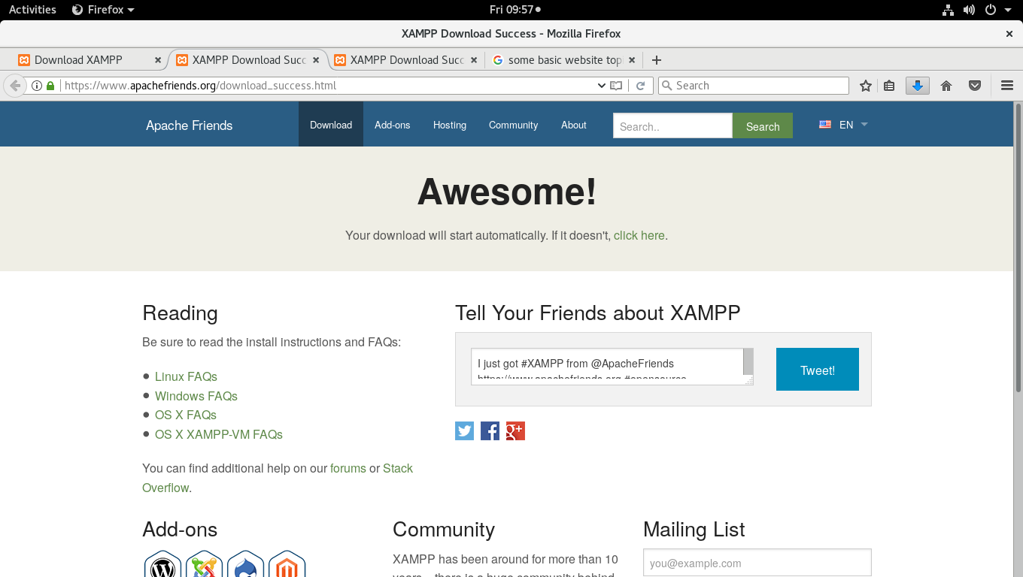

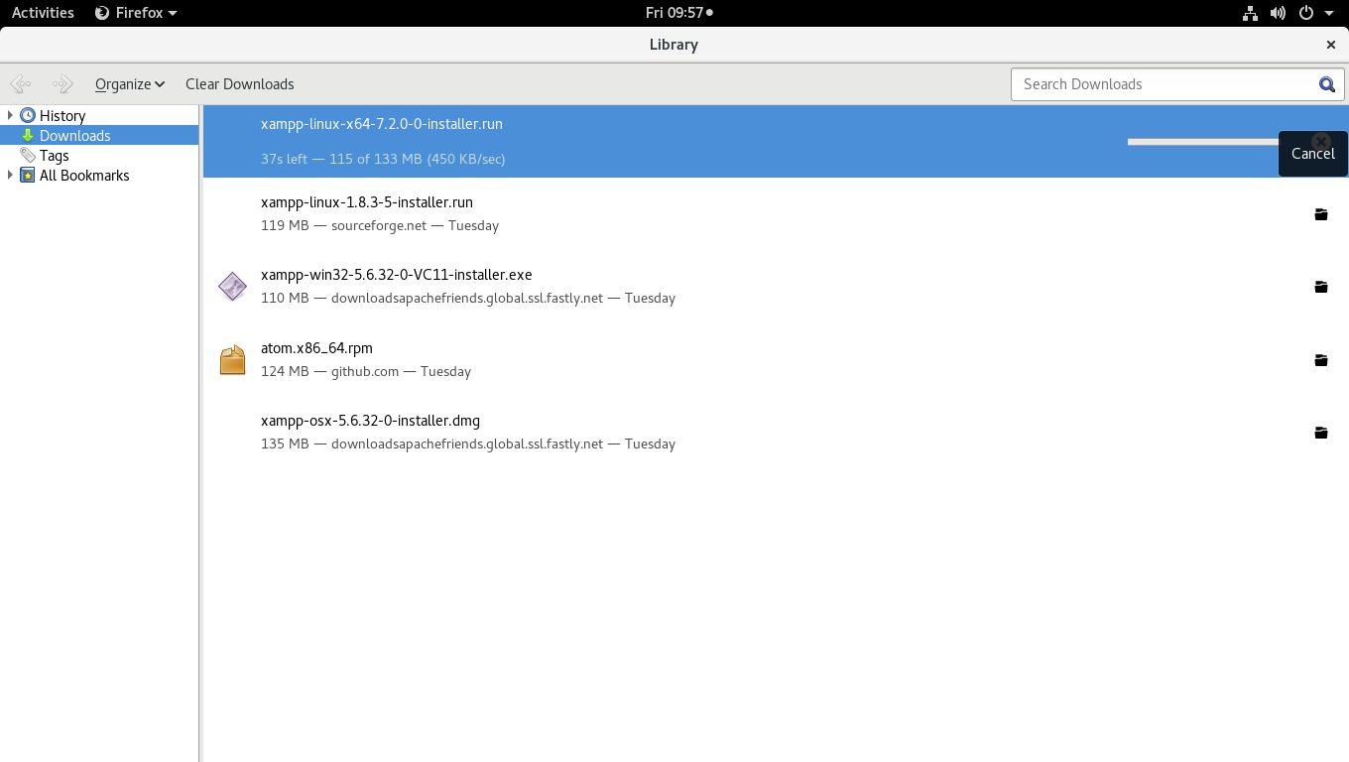
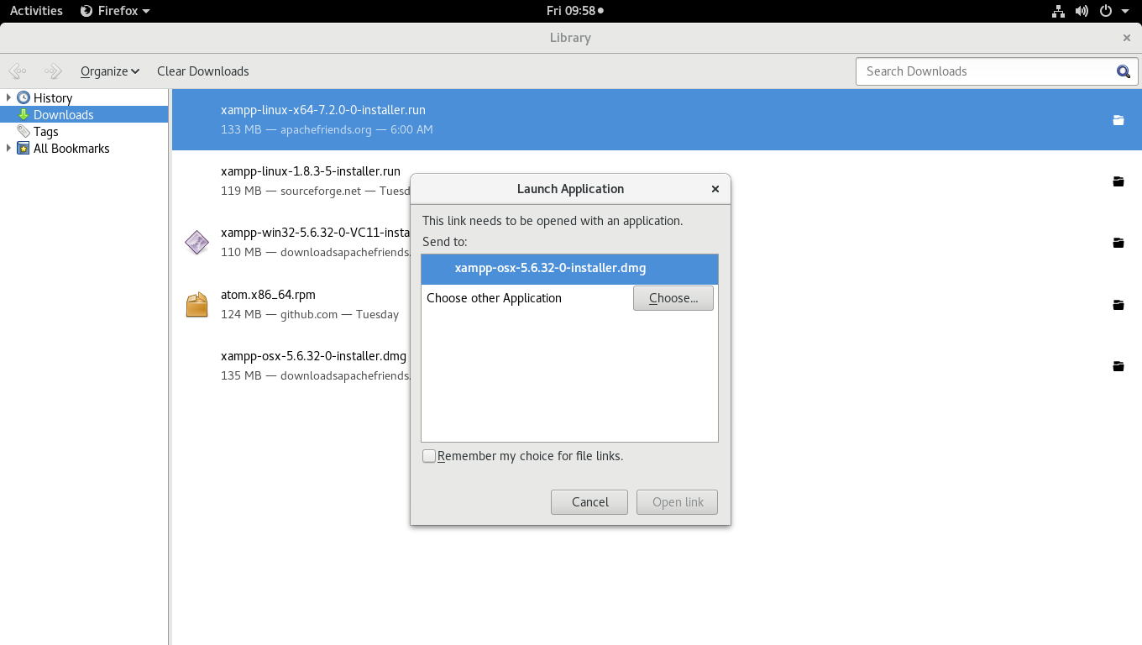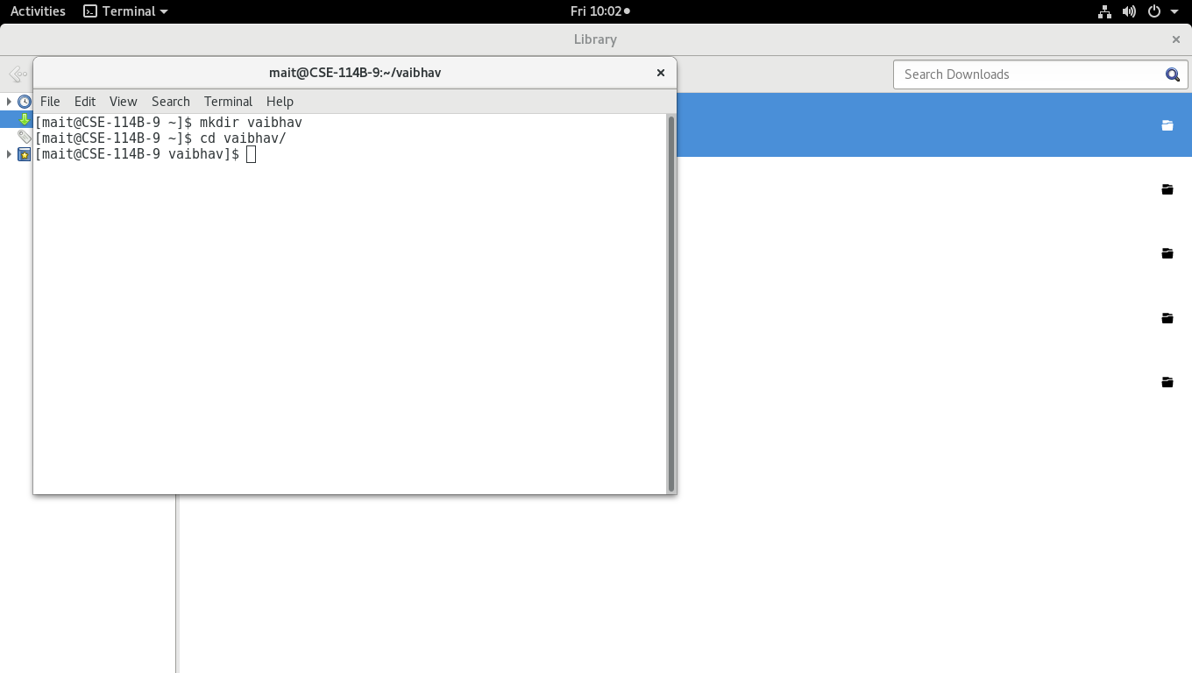

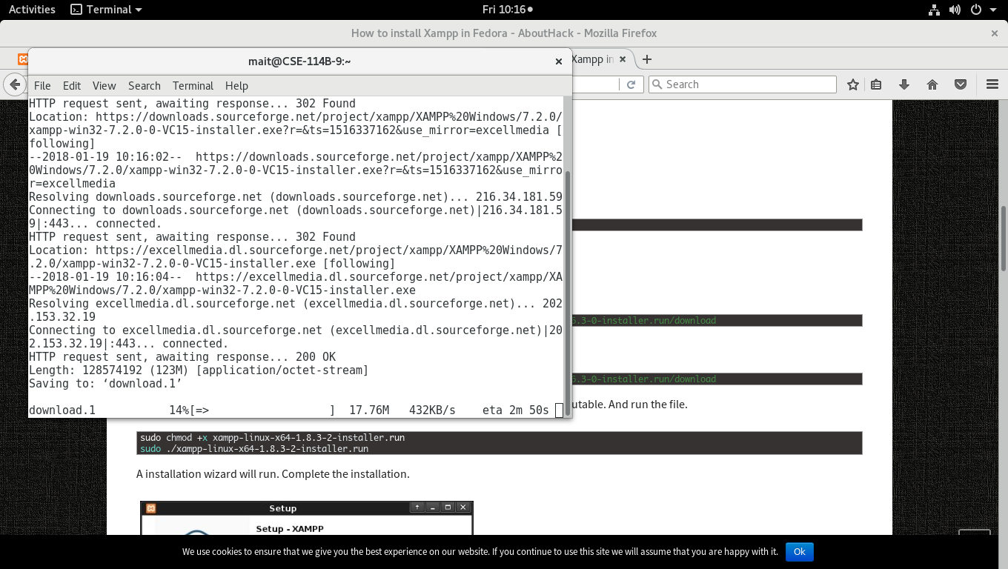
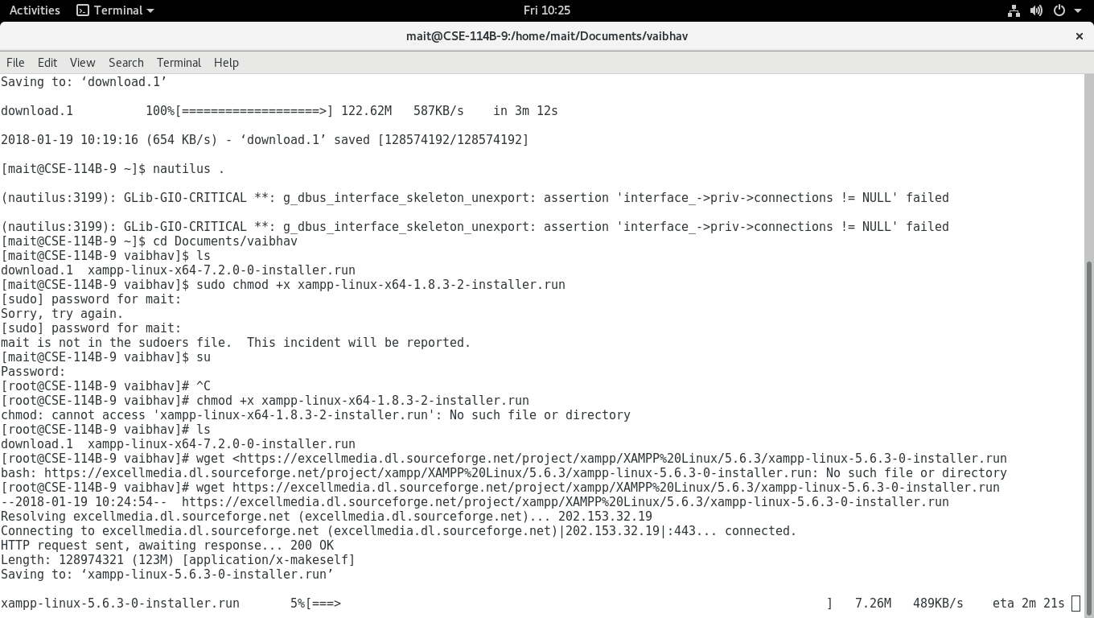
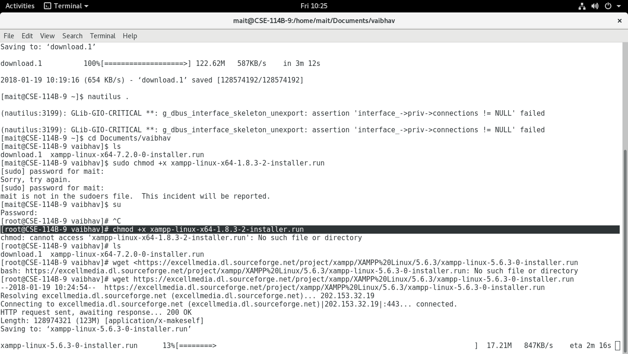
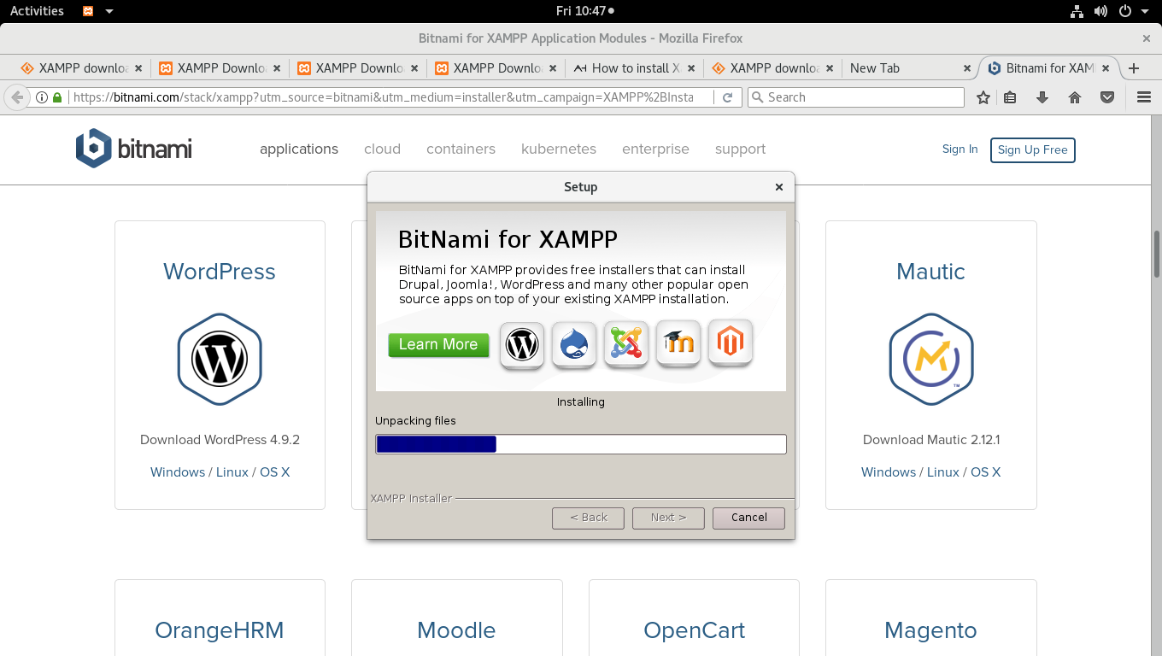
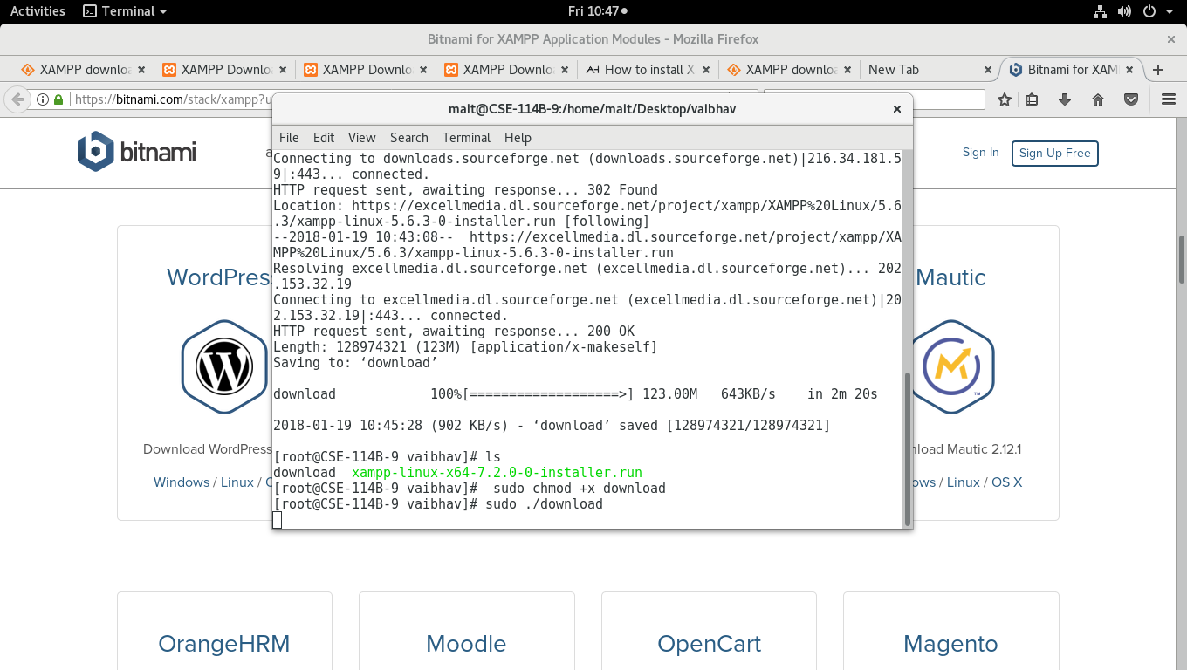
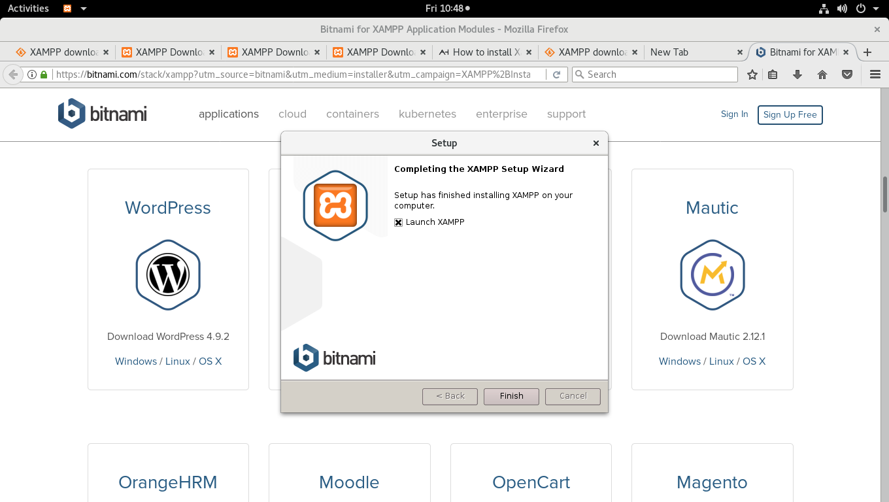
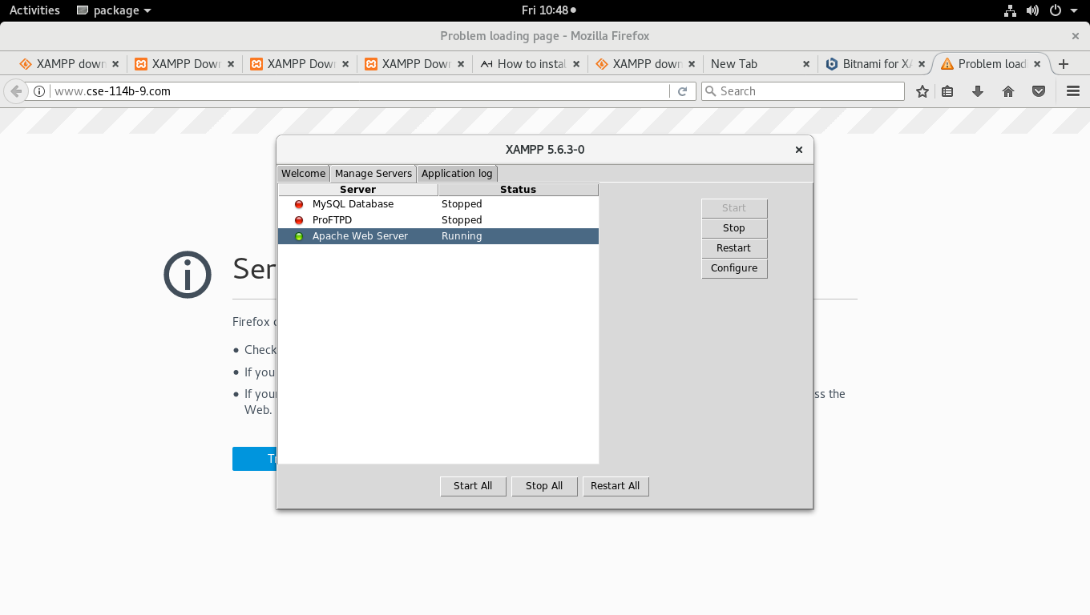
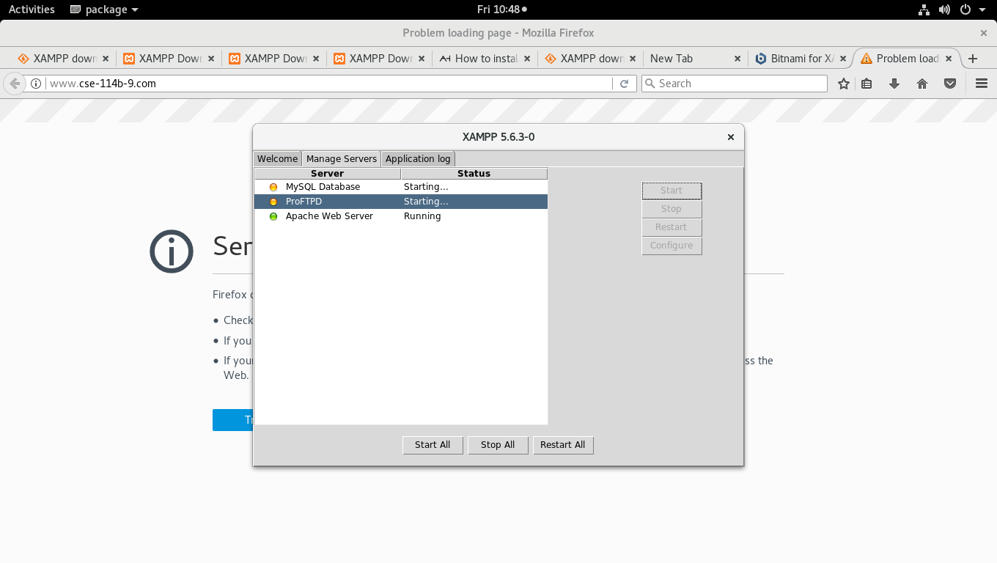
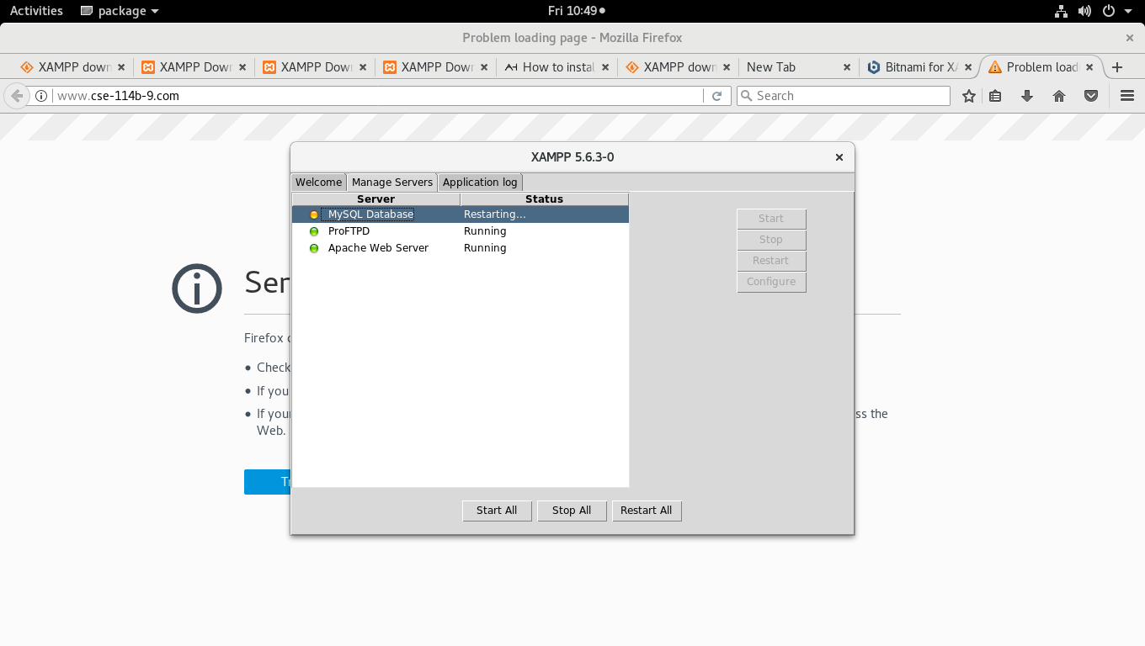
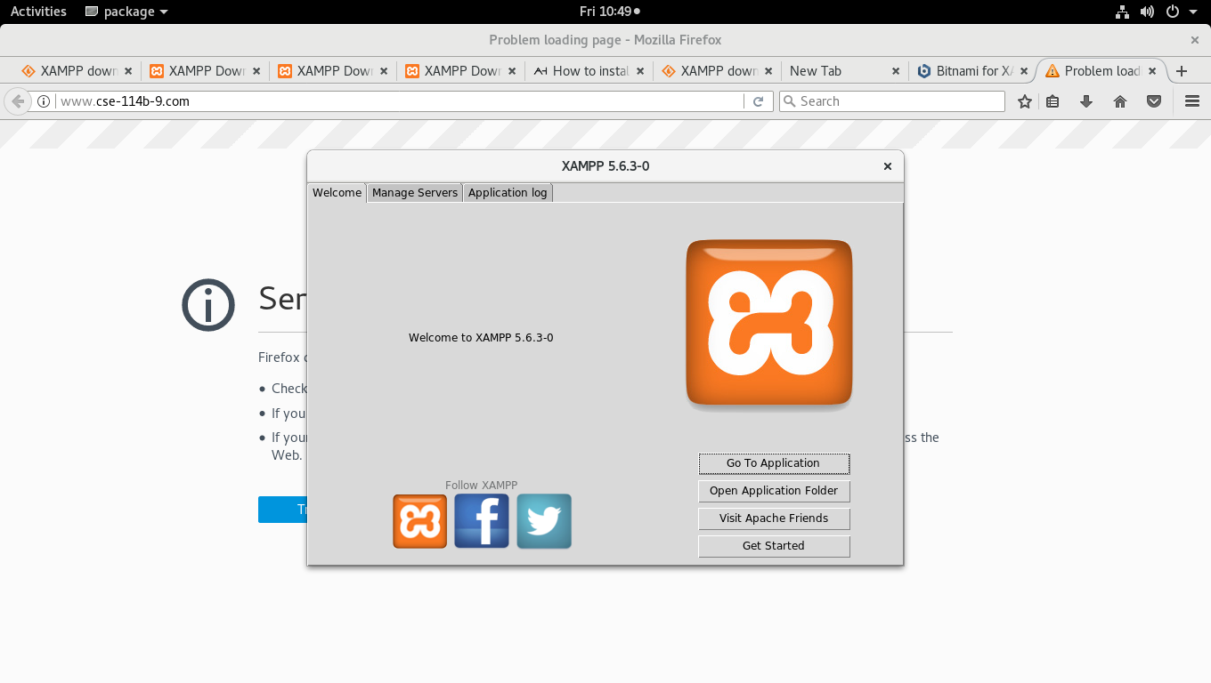
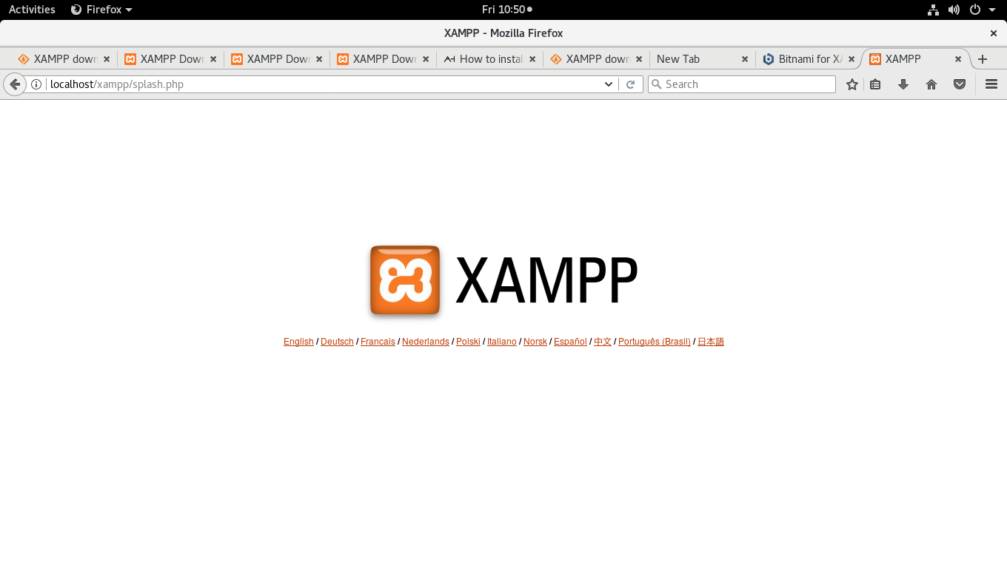
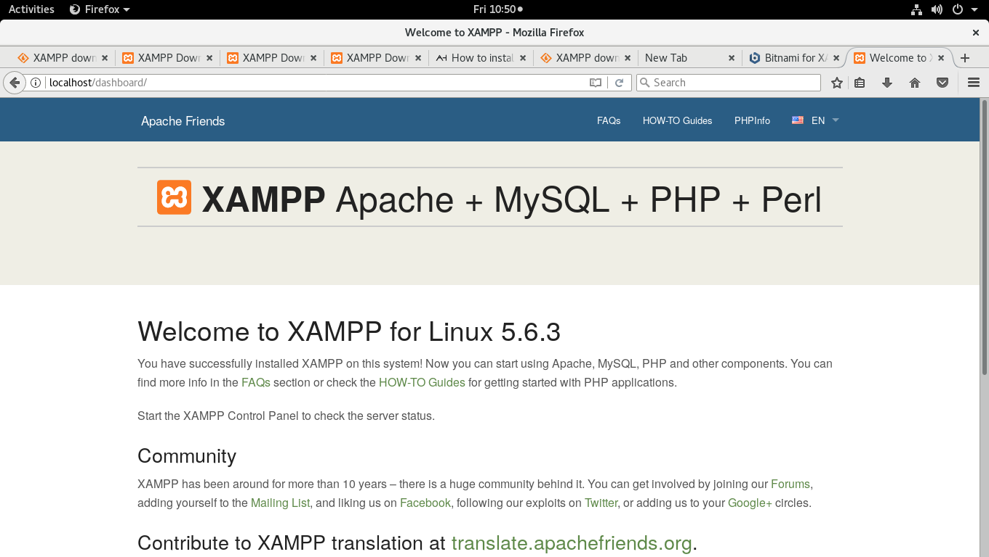

HTML Source Code

<!DOCTYPE html PUBLIC "-//W3C//DTD XHTML 1.0 Transitional//EN" "http://www.w3.org/TR/xhtml1/DTD/xhtml1-transitional.dtd">
<html xmlns="http://www.w3.org/1999/xhtml">
<head>
<title>News Website</title>
</head>
<body>
<p>NEWS Website</p>
<p>
Menu Items</br>
Daily News</br>
Sports</br>
Business</br>
Politics</br>
Entertainment</br>
Technology &amp; Science</br></p>
<p>
<img src="images/image_01.jpg" alt="image" />
</p>
<p>
<h2>General News</h2></br>
<img src="images/image_08.jpg" alt="image" />
</p>
<p>
<h2>Sports</h2></br>
Badminton</t> Table Tennis
</p>
<p>
<h3>Tab Section</h3>
Health</br>
Entertainment</br>Politics</br>Business</br>Tech &amp; Science</p>

